**Explanation of top Command Output**

**The top command in Linux is a powerful tool for monitoring system performance and processes in real time, detailed explanation of its output :**

*Explaining each and every term with respect to below output*



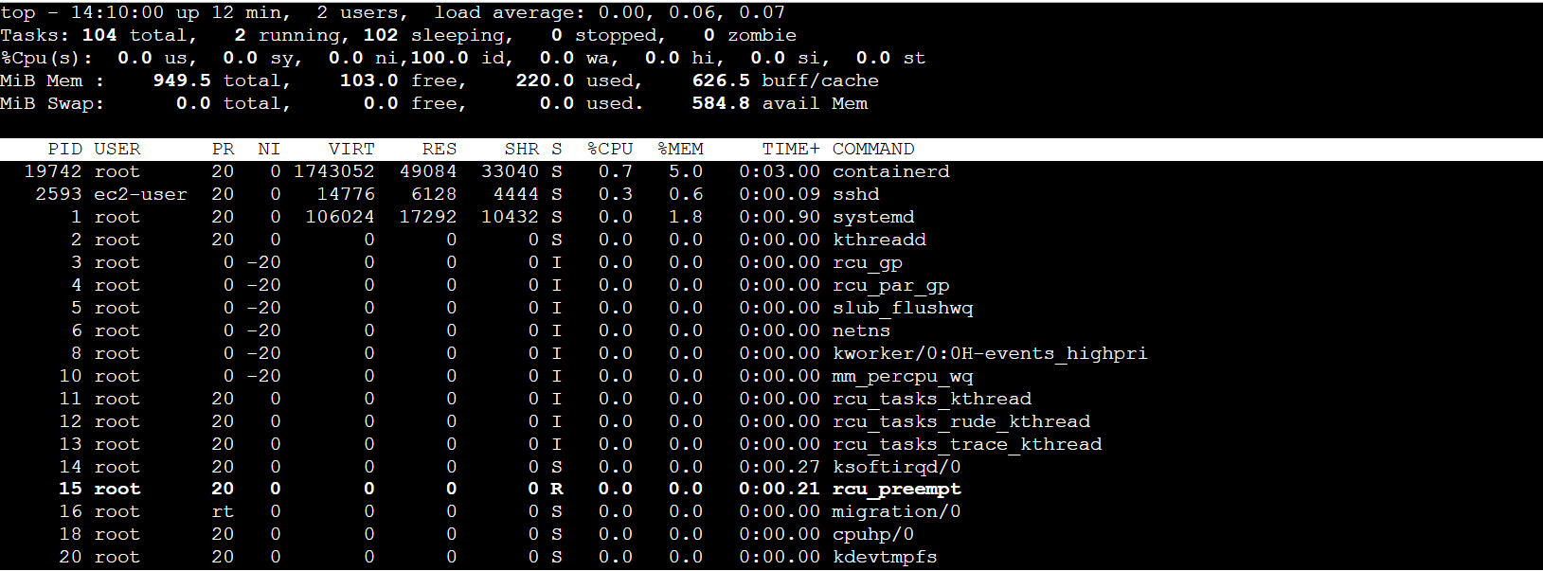

*top - 14:10:00 up 12 min, 2 users, load average: 0.00, 0.06, 0.07*

*Tasks: 104 total, 2 running, 102 sleeping, 0 stopped, 0 zombie*

*%Cpu(s): 0.0 us, 0.0 sy, 0.0 ni, 100.0 id, 0.0 wa, 0.0 hi, 0.0 si, 0.0 st*

*MiB Mem : 949.5 total, 103.0 free, 220.0 used, 626.5 buff/cache*

*MiB Swap: 0.0 total, 0.0 free, 0.0 used. 584.8 avail Mem*

*PID USER PR NI VIRT RES SHR S %CPU %MEM TIME+ COMMAND*

-----------------------------------------------------------------------------------------------------------------

***top - 14:14:24 up 16 min, 2 users, load average: 0.00, 0.02, 0.05***

***14:10:00 =*** *Current system time*

***up 12 min =*** *Up time of OS*

***2 users =*** *Number of logged-in users*

***load average =*** *Average system load over the :*

* *0.00 = last 1 minutes*
* *0.06 = last 5 minutes*
* *0.07 = last 15 minutes*

*-----------------------------------------------------------------------------------------------------------------*

***Tasks: 104 total, 2 running, 102 sleeping, 0 stopped, 0 zombie***

***Tasks: 104 total =*** *Total number of processes.*

***1 running =*** *Processes actively running on the CPU*

***102 sleeping =*** *Processes waiting for resources or in idle state.*

***0 stopped =*** *Processes stopped (via Ctrl+Z).*

***0 zombie =*** *Zombie process like a task that is done, but its name is still on a to-do list because the parent hasn’t crossed it off yet. It’s not working or using resources—just waiting for the parent to clean it up.*

*-----------------------------------------------------------------------------------------------------------------*

***%Cpu(s): 0.0 us, 0.0 sy, 0.0 ni, 100.0 id, 0.0 wa, 0.0 hi, 0.0 si, 0.0 st***

***0.0 us (****user****) =***  *This is the* ***CPU consumed by the programs you run****. If you're using apps like a web browser or text editor, this time represents how much CPU is used for those tasks.*

***0.0 sy (****system****) =*** *This is the* ***CPU consumed by the operating system****. It’s the CPU time spent by the kernel (the core part of the operating system) managing things like memory, hardware, and processes.*

***ni (****nice****) =*** *This shows the* ***CPU consumed by lower-priority tasks****. Sometimes processes are marked as "nice," meaning they are less important, and they get less CPU time.*

***100.0 id (****idle****) =*** *This is the* ***time when the CPU is not doing anything****. If the CPU is sitting idle, it’s not working on any tasks, so this is the unused time.*

***0.0 wa (iowait)*** ***=****This shows the* ***CPU waiting for data*** *from storage or disk. If your computer is waiting for something to load from your hard drive or SSD, this time is counted as "iowait."*

***hi (****hardware interrupts*) ***=*** *This is the* ***CPU consumed by handling hardware requests****. For example, when you press a key on the keyboard, the CPU handles that interrupt.*

***si (software interrupts)*** *=**This is the* ***CPU consumed by handling software requests****. It’s like the CPU processing instructions from the operating system or programs that ask for CPU attention.*

***St (****steal time****) =*** *This shows the* ***CPU that is being used by other virtual machines*** *(in a virtualized environment). If you're using cloud services or virtual machines, some of the CPU time might be used by other virtual machines running on the same physical hardware.*

*-----------------------------------------------------------------------------------------------------------------*

***MiB Mem : 949.5 total, 103.0 free, 220.0 used, 626.5 buff/cache***

***949.5 total =*** *Total physical memory.*

***103.0 free =*** *Memory not used.*

***220.0 used =*** *Memory in use.*

***626.5 buff/cache =*** *Memory used for buffers and cache.*

*-----------------------------------------------------------------------------------------------------------------*

***MiB Swap: 0.0 total, 0.0 free, 0.0 used. 584.8 avail Mem***

***0.0 total =*** *Total swap space available.*

***0.0 free =*** *Swap space not used.*

***0.0 used =***  *Swap space in use.*

***584.8 avail Mem =*** *Estimated amount of memory available for starting new applications (includes unused + cached memory).*

*-----------------------------------------------------------------------------------------------------------------*

***PID USER PR NI VIRT RES SHR S %CPU %MEM TIME+ COMMAND***

***PID =*** *Process ID (kernel understand PID only)*

***USER =*** *The user who owns the process*

***PR =*** *Process priority (lower values = higher priority)*

***NI =*** *Nice value (used to adjust priority)*

***VIRT =*** *Virtual memory size used by the process*

***RES =*** *Resource, actual memory used*

***SHR*** ***=***  *Shared memory size, Imagine two programs, A and B, both need to use the same data (like a library or file). Instead of each program making its own copy of that data, they both use the* ***same shared memory***.*So,* ***SHR*** *tells you how much memory is being shared between different programs.*

***S =*** *Process state, process states are :*

* *R: Running*
* *S: Sleeping*
* *D: Uninterruptible sleep*
* *Z: Zombie*
* *T: Stopped*

***%CPU =*** *Percentage of CPU used by the process.*

***%MEM =*** *Percentage of physical memory used by the process.*

***TIME+ =*** *It is the total amount of time the CPU has spent working on a particular process. This is shown in* ***minutes*** *and* ***seconds*** *.For example, if a process is running for a long time,* ***TIME+*** *will keep increasing because it’s consuming more CPU time over its lifetime.*

***COMMAND =*** *The name or command line of the process.*

*-----------------------------------------------------------------------------------------------------------------*

***In the top command, you can use various key commands to sort and manage the process list.***

***P*** *= Press* ***P*** *to see the maximum CPU utilization by the process.*

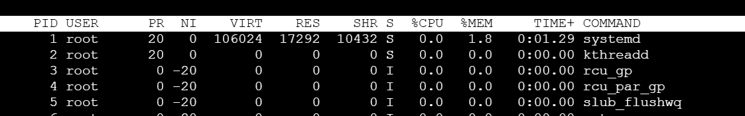

***M*** *= Press to see the maximum RAM utilization by the process.*

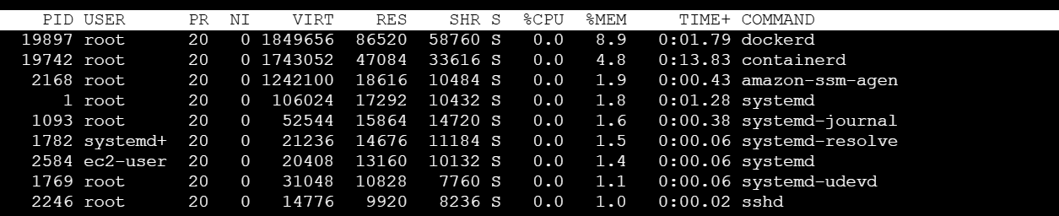

***Z =*** *To change color.*

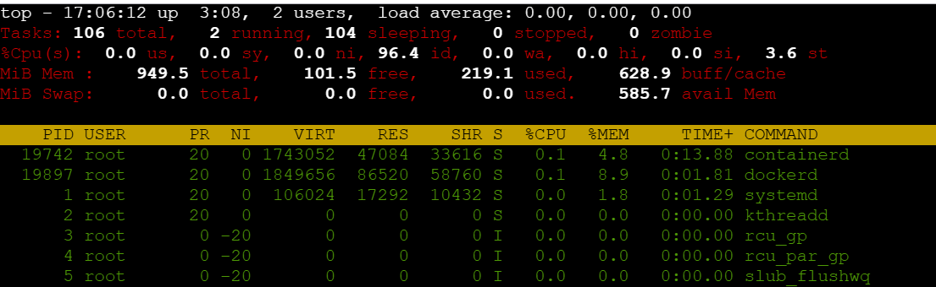

***h =*** *For help.*

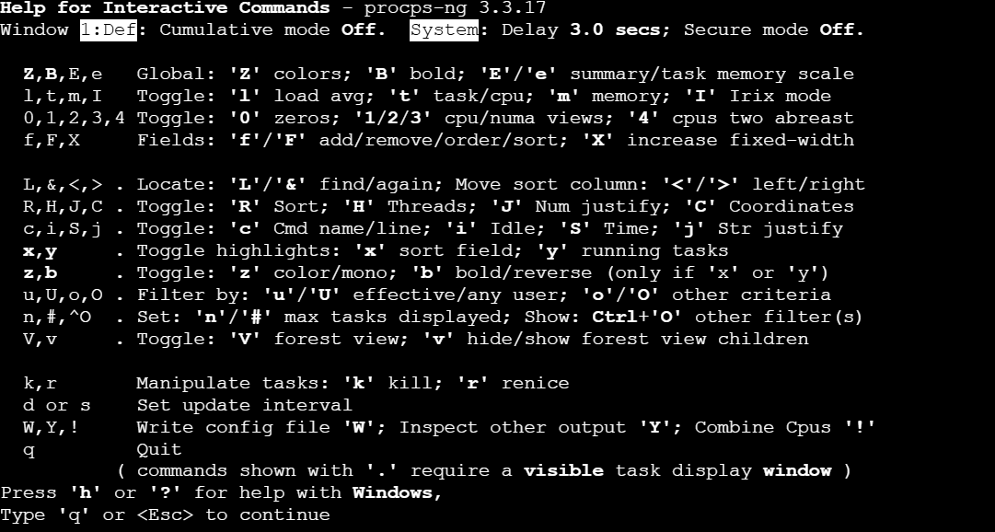

***u =*** *To see task by specific user.*

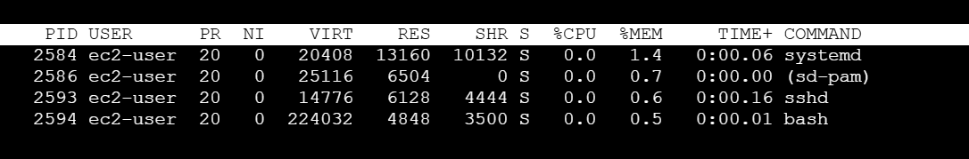

***T*** *= Pressing* ***T*** *will sort processes by how long they have been running.*

***k*** *=Pressing* ***k*** *allows you to enter the PID (Process ID) of a process you want to kill (stop).*

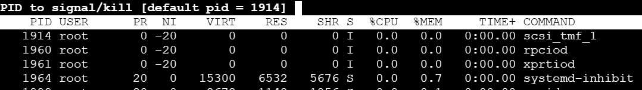

***r*** *= press* ***r*** *to renice a process, which changes its priority for CPU time.*

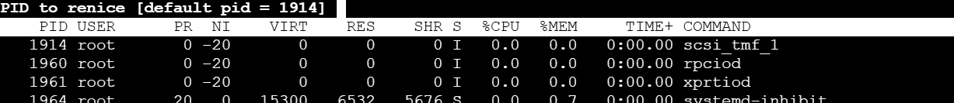

***q*** *= Press* ***q*** *to exit top.*